Improved File Security System Using Multiple Image Steganography

1.INTRODUCTION:
Designing a system for secret communication using multi-image steganography and face recognition. The aim of this project is to provide security for data sent over the network between two or more people. We use advanced technology, which is the OTP system in our project, to enhance the security level of information security. has become a prime issue of worldwide concern. To improve the validity and proficiency of the image data-hiding method, a cutting-edge secret information concealment transmission scheme based on face recognition is proposed. On the sender and receiver sides, we use the face recognition technique for fetching the sender and receiver secret messages, and the advanced technology we use is OTP technology. This technology can help to pass the secret messages to the receiver without any interference. The scope of the project is the implementation of steganography tools for hiding information including any type of information file and image file and the path where the user wants to save the image and extruded file. We use the LSB technique. The proposed approach is to use a steganography algorithm for embedding data in the image files for military applications. For security purposes we used modules face Recognition technique with AES algorithm for Strong Security purpose. And we use the cover channel technique as an information hiding technique that can be exploited by a process to transfer information in a manner that violates the system security policies. And we use copyright marking techniques.
  - Objective of the project:
Our Proposed system is to develop a Web Application for hiding information in any image file to ensure the safety of the exchange of data between different military parties and provide better security during message transmission. The scope of the project is the implementation of steganography tools for hiding information including any type of information file and image file and the path where the user wants to save the image and extruded file. We use the LSB technique. The proposed approach is to use a steganography algorithm for embedding data in the image files for military applications. For security purposes we used modules face Recognition technique with AES algorithm for Strong Security purpose. And we use the cover channel technique as an information hiding technique that can be exploited by a process to transfer information in a manner that violates the system security policies. And we use copyright marking techniques. In short, Cover Channels transfer information using non-standard methods against the system designed. Deep learning techniques used for image steganography can be broadly divided into three categories - traditional methods, Convolutional Neural Network-based and General Adversarial Network-based methods. Along with the methodology, an elaborate summary on the datasets used, experimental set-ups considered and the evaluation metrics commonly used are described in this paper. A table summarizing all the details are also provided for easy reference. This paper aims to help the fellow researchers by compiling the current trends, challenges and some future direction in this field.
2. LITERATURE SURVEY:
1.Covering Image Steganography Using Morphed Face Recognition Based on Convolutional Neural Network
To improve the validity and proficiency of the image data hiding approach, a piece of state-of-the-art secret A scheme for concealing information transmission based on morphed face recognition is proposed. In our proposed A group of morphed face images is created from an arranged small-scale face image using the data-hiding approach dataset.
Then, a morphed face image that is encoded with a secret message is sent to the receiver. The receiver uses powerful and robust deep learning models to recover the secret message by recognizing the parents of the morphed face images. Furthermore, we design two novel convolutional neural networks (CNNs). architectures (e.g., MFR-Net V1 and MFR-Net V2) to perform morphed face recognition and achieved the highest accuracy compared with existing networks.
Additionally, the experimental results show that the proposed schema has a higher retrieval capacity and accuracy, and it provides better robustness.
2. Image Steganography: A Review of the Recent Advances
Image steganography is the process of hiding information, which can be text, image, or video, inside a cover image.
The secret information is hidden in a way that it is not visible to human eyes. Deep learning technology, which has emerged as a powerful tool in various applications, including image steganography, has received increased attention recently.
3. Secure Data Transmission
Any type of communication over the internet and other network applications needs to be secure due to their increasing utility. For this task, lots of algorithms for security have been implemented and used so far. Up until now, cryptography has been the mainstay for defending secure data transmission. With the increasing threat, steganography has also taken up space for security purposes.
In cryptography, we change the natural form of data by using different security algorithms, which leads to increasing the security of the communication process. In steganography, information is kept hidden from the attacker for securely communicating information through the use of images, audio, video, and so on for more We proposed a method for ensuring data transmission security by utilizing both cryptographic techniques, and steganography.
In cryptography, we will perform three-level encryption with the use of the AES, DES, and Blowfish algorithms. LSB will be used in steganography to embed the data file in any audio, video, or image. DWT and DCT techniques, and then we will communicate the secure data to the receiver end.
In this new research idea, which they explained, the goal was to use the above-mentioned algorithms together to increase the level of security multiple times. The key point of their proposed work is that they can encrypt the data file in any of the desired orders.
After successfully completing all levels of encryption, they will move on to steganography.
In steganography, they will select a video, audio, and image file that is to be merged with the encrypted file. They will now choose the file with the ”.blowfish” extension and embed it in the video file. After that, the file will be transferred to the receiver.
4. An efficient steganographic technique for hiding data
Steganography is a technique for hiding data that aims to hide data in such a way that any eavesdropper cannot detect it. cannot observe any changes in the original media. Image steganography is the most common and widely used method. with reference to other types of steganography least significant bit (LSB) is one of the most public techniques in steganography. The classical technique is LSB substitution.
The main idea of this technique is to directly alter some LSB of the cover image with the secret data. The The essential drawback of the available LSB techniques is that increasing the capacity of the stego image leads to decreasing its quality. Therefore, the goal of the proposed method is to enhance the capacity of high visual quality into consideration.
To achieve this goal, some LSBs of the cover image are inverted depending on the secret data for embedding. instead of replacing LSB with secret data. First, the maximum and minimum values in the secret data are determined, then subtract all values of the secret data from this maximum value.
The following steps are for hiding secret data (the embedding algorithm) and the steps for retrieving secret data (the extracting algorithm).
Finally, make a division for the results and embed the new results into the cover image to obtain the stego image. The results show that the proposed method gives high capacity and good imperceptibility in comparison with the previous methods.
5. Combination of Steganography and Cryptography
The establishment of secure communication between two communicating parties is becoming a difficult problem due to the likelihood of attacks and other unintentional changes during active communication over an unsecured network.
The security of secret information can be secured using either cryptography or steganography. Steganography refers to the practice of concealing a message (with no traceability) in a manner that it will make no meaning to anyone else except the intended recipient, while cryptography, on the other hand, refers to the art of converting a plaintext (message) into an unreadable format.
Thus, steganography conceals the existence of a secret message while cryptography alters the message format itself. Both steganographic and cryptographic techniques are powerful and robust.
Steganography and cryptography have been noted to be individually insufficient for complete information security. Therefore, a more reliable and strong mechanism can be achieved by combining both techniques. Combining these strategies can ensure improved secret information security and will meet the requirements for security and robustness for transmitting important information over open channels.
6. Hiding text in a gray image using mapping technique
In order to hide the significant and secret message inside a cover object, Steganography is considered one of the most used techniques because of its strength.
This paper presents a new steganography technique that is difficult to discover or break by a third party. The ASCII Mapping Technique (AMT) is used to create an encoded table by mapping the text message and matching some bits with that of the cover image.
The system saves the character parts matching and the location of which part of the pixels. Then change the related flag from zero to one for matched locations so that they cannot be used again to strengthen the technique and make it more secure.
The main idea of the proposed algorithm is to divide each character (8-Bits) of the secret message into two bits and then search the image pixels for the two similar bits in that image (Each pixel in the gray image has 256 gray scales, i.e. in the representation of one pixel in the gray image we need one byte). As an expected result of this method, the probability of finding matching pixels that are in relation to characters of the secret messages.
The proposed technique was tested and showed low computational cost with effective performance to be used for multi-purpose applications.
3. SYSTEM ANALYSIS
3.1 Existing System
In existing system uses machine learning algorithms like random forest, svm, knn etc. By using these algorithms there is no improvement in file security of the system.
Disadvantages
1.Less prediction
2.Takes more time
3.2 Proposed System
To protect and recover the secret information more effectively, we propose an improved image steganography framework adapting to neural style transfer, consisting of an encoder network, a style transfer network, and a decoder network. By introducing the Y channel information and a novel structural loss to restrain the training of decoder and encoder networks, the encoder can effectively embed the gray-scale secret image into the Y channel of the cover image, and the decoder can directly obtain the original secret information from the stylized stego image. The experimental results demonstrate that the proposed framework can realize better embedding and extraction of the gray-scale secret image before and after the style transfer. The PSNR between the decrypted secret image and the original secret image can reach 23.4, and most of the details and semantics are retained. Therefore, the proposed framework can not only basically maintain most of the hidden information in the stego image during the stylization process, but also better recover the secret image with almost the same visual effect from the stylized stego image. That is, steganography attacks can be better avoided and secret private information such as copyright can be protected to a certain extent.
Advantages
1.It improves file security
2.More prediction
3.3. Procedure MODEL USED WITH JUSTIFICATION
TheSDLC(UmbrellaModel)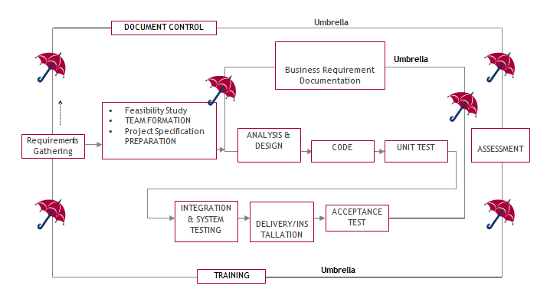
It stands for the software development process. The software industry utilises it as a standard to produce high-quality software.
The requirement collection, evaluation, development,coding, testing, and maintenance phases make up the SDLC.
Requirements assembling phase:
During the requirements gathering process, the goals specified in the development plan's high-level needs section are utilised as input. For each target, a set of particular requirements will be created. These requirements include operational data regions, data entry sectors, and the initial data entities in addition to the main functionality of the projected application. Major roles include handling mission-essential materials, results, and reports as well as vital procedures that must be managed. A client class hierarchy connects these essential operations, data areas, and data entities. One of these definitions is a necessity.
Requirements are identified by unique need IDs and must include a title and an oral description at the very least. 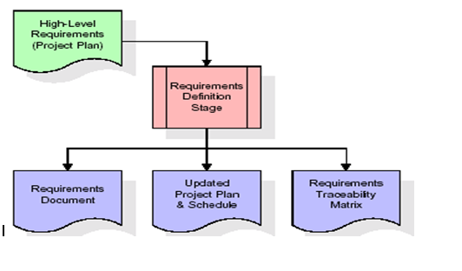
the standards These requirements are thoroughly defined in the specification and the needed chart of traceability (RTM), that provide as this stage's key deliverables. The requirements document provides a detailed description of each need along with any necessary drawings and exterior document references. It should be noted that database column and table types are not fully described in the requirements paper.
The first drafting of the RTM also contains the titles of each need in addition to the names of each target from the project plan. The purpose of the RTM is to show the formal relationships between the product components produced at each stage of the software development process and those produced at prior stages.
The RTM contains a list of excellent requirements, or goals, categorised by goal title for each stage and a list of associated requirements for each goal. Each need established at this step is directly linked to a specific product goal, as shown by the RTM's organised listing. The term "requirements traceability" describes the framework through which each demand may be connected to a specific product goal.
The outcomes of the specification defining stage are the standards documents and the RTM, and an amended project plan.
• Finding any project-related concerns is the major objective of a feasibility study.
Project demands are all about demonstrating all of the data that could possibly be sent to the the computer and associated outputs, along with observations that are kept up to today by the the administrator. A Team Creation is utilised for demonstrating the number of personnel needed to complete an endeavour; in this case, simply elements are the duties that will be given by the team participants engaged in that project.
Analysis Stage:
The planning stage uses a bird's-eye view of the planned software product to develop a basic project structure, evaluate the project's feasibility and risks, and specify the most effective technical and management approaches. 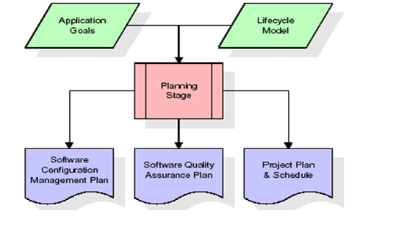
The most crucial element of the project plan is the set of high-level product requirements, sometimes referred to as goals. All of the requirements for the application that are produced during the process of defining requirements are built upon at least one of these goals. Each aim must have an abstract and a textual description, but it is also acceptable to incorporate additional information and references to other sources. Byproducts of the project's planning phase include the undertaking's schedule and plan, the quality assurance plan, and the establishment of the follow up maintenance plan. A comprehensive description of expected tasks for the next needs stage is included in the project's plan and calendar, along with an overview projection for effort for the succeeding stages.
Design Phase:
The initial contribution from the design stage is the criteria mentioned in the permitted requirements document. For each need, discussions, meetings, and/or prototype development will result in the creation of an ensemble of any number of design components. Design elements often include dummy code, an extensive entity-relationship atlas with a complete data dictionary, interface layout schematics, databases for business rules, operational hierarchy diagrams, corporate workflow diagrams, and tables for company rules. The necessary software functionalities are thoroughly explained in these components. These design elements are intended to sufficiently specify a programme so that competent programmers may construct it with minimum more assistance. 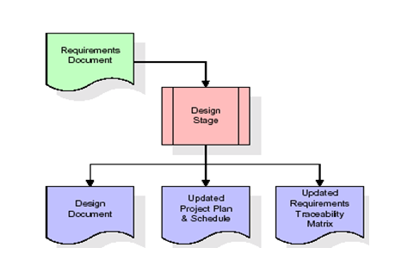
Whenever the building document is finished and accepted, the RTM is amended to reflect formal links between each design feature and a specific need. The results of the conceptualization stage include a design record, an updated Rpm effect, and a new project plan.
Stage of development (coding):
The key contribution of the development stage is the design elements consisted of in the style that has been authorised document. For each design element, a set of several programming objects will be produced. Software artefacts include, but are not limited to, menus, conversation boxes, storage forms, information reporting formats, and speciality operations and functions. An online assistance system will be developed to guide users as they interact with the product, and appropriate tests will be produced for each set of functionally related software artefacts. 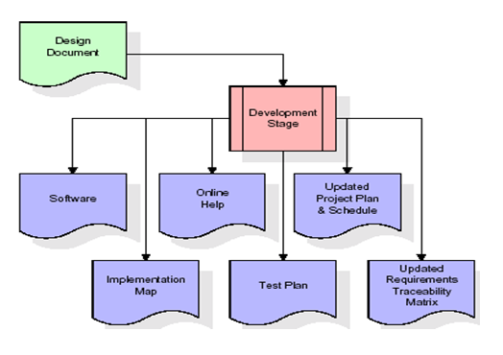
The RTM will be changed to reflect that each produced artefact has a corresponding example item and is associated with a specific design element. Currently configured to its ultimate configuration, the RTM. The end result of the development process is a fully functional set of software that adheres to the requirements and layout elements previously stated, a working assists framework that demonstrates how to use the programmes, an implementation link that regulates the principal developing entry points to feed each of the major features of the system as a whole, a testing strategy that describes the sets of examinations to be employed in checking the correctness and breadth about the app, resulting in an informed RTM, and the updated project.
Stage of Integration & Testing:
During the integration and test step of the process, programme artefacts, online assistance, and test information are transported from the developing environment to a distinct test environment. The software is now being put through all of the testing to ensure correctness and completeness. The successful completion of the test suite validates a robust and all-encompassing migration capability. Throughout this period, which also entails the conclusion of data references for production use, production users are identified and linked to the appropriate roles. The synthesised initiation plan contains connections to the source material for the concluded reference data as well as creating the user list and the final results for reference. 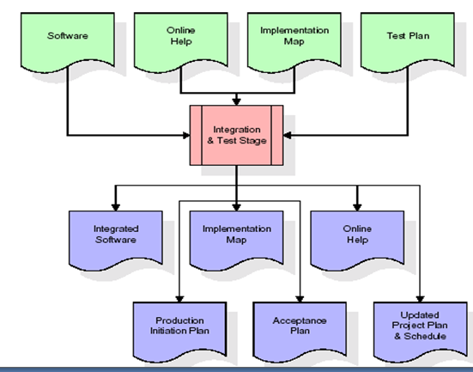
Among the outcomes of the application and validation stage are a full set of programmes, an online encouragement framework, a distribution visualise, an assembly admission technique that illustrates a connection data as well as data for making subscribers, an agenda for acknowledgment incorporating the last batch of examples, and a fresh business strategy.
Installation and acceptance testing
During the setup and acceptance phase, a production site gets populated with the software components, online help, and first production data. The software is now being put through all of the testing to ensure correctness and completeness. A series of tests must pass before the client will accept the software. After customer staff has verified that the very initial round of information to load is correct and the testing location has been successfully completed, the client formally authorises the delivery of the programme. 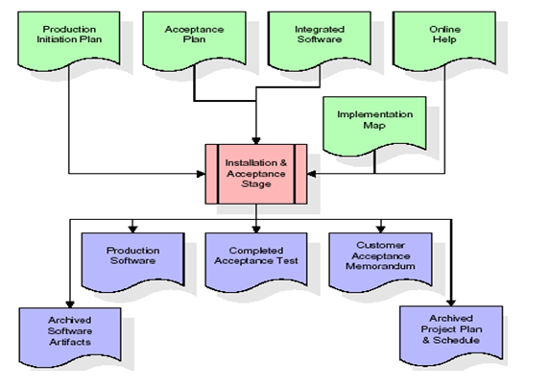
The major outputs of the setting and acceptance stage are the finished version of the application, a completed tolerance test apartment, and a note of customer approval of the programme. The rest of the actual labour data is subsequently added to the project itinerary by the PDR, which locks the endeavour as a final project record. The prototype development vault "locks" the venture at this point by preserving the entire software factors, the install mapping, the original code, and its original material manuals for subsequent use.
Maintenance:
The outside rectangle shows project upkeep. The maintenance team will start by reviewing the specifications and deciphering the documentation. Workers will then be allocated jobs and get retraining for that particular group. This life cycle has neither beginning or conclusion; it goes on indefinitely resembling the sticks that make up of an umbrella.
3.4 Software Requirement Specification
3.4.1. General Summary
Software requirements documents (SRS), usually referred to as a collection of demands for an application, provide a thorough description of the characteristics of a system that must be built. It provides a selection of use examples outlining all of the encounters that users will have with the application. Along with use cases, the SRS includes non-functional requirements. Non-functional requirements are those that impose constraints on the project's planning or execution. They are sometimes referred to as efficiency needs, norms regarding quality, or design restraints.
System requirements specification: a well-organized collection of data that outlines a system's requirements. A business analyst, often referred to as an information analysts, they might is in charge of analysing the business needs of their stakeholders and clients in order to spot problems and provide solutions. When it comes to the systems development lifecycle, the BA often acts as a point of contact between the corporate side of a company and its technical unit or outside service providers. Projects must adhere to three distinct categories of criteria:
Business requirements specify the tasks or materials that must be performed in order to provide value.
The qualities of a system or product are specified by its product requirements, which may be one of various ways to address a set of business demands.
• Process requirements list the duties performed by the expanding business. For example, process requirements could describe. The feasibility of the project and the likelihood that the structure would benefit the organisation are the two main topics of the first investigation. Determining whether it is formally, operationally, and economically possible to add new modules and make repairs to current systems is the main objective of the feasibility study. Every system works if there are unlimited resources and time. The following components make up the feasibility study for the preliminary investigation:
FINANCIAL SUITABILITY
A system may be developed technically, but before it can be used, the organisation must decide that it is a worthwhile investment. In a feasibility study, the system's development costs are compared to the benefits of the new structures in terms of overall value. Benefits must be equal to or greater than costs in the sense of money. The system is affordable to install. There is no need for extra gear or software. Since the connection for this network was made using the tools and equipment existing in use at nic, there is low investment and obvious commercial viability.
Operational Feasibility
Although a system may be technically constructed, the organisation must determine that it is a worthy investment before it can be employed. The system's development expenses are contrasted with the advantages of the novel components in terms of total value in an economic impact assessment. Benefits must be at least as much as expenses in financial terms. Installing the system is reasonably priced. Additional hardware or software are not required. There is a cheap investment and clear commercial feasibility since the network connection was built utilising the equipment and resources that were already in use at NIC.
TECHNICAL FEASIBILITY
There was no system in existence before this one to fulfil the requirements of the "Secure Internet Implementation System." Technically speaking, the current system is functional. The NIC-CSD audit process has a web-based user interface. It provides customers with easy access as a consequence. The database's objective is to build, administer, and support procedures for all engaged customers in their different roles or capacities across several businesses. The users would get authorization in accordance with the duties specified. It provides the technical guarantee of security, reliability, and accuracy as a consequence.
3.4.2. External Interface Requirements
User Experience
This system's user interface is made in an approachable Python visualisation.
Device Interfaces
In order to facilitate communication between an operator and the console, Python features are employed.
Interfaces in software
Software built using Python is required.
Operating Conditions
Microsoft Windows XP.
Hardware specifications:
Pentium-IV processor with a speed of 1.1 GHz, 256 MB of RAM, 20 GB of hard drive space, a standard Windows keyboard, a two- or three-button mouse, and an SVGA monitor are required.
software prerequisites:
Windows 7/8 is the operating system, while Python is the programming language.
4. SYSTEM DESIGN:
UML Diagram:
Class Diagram:
The class diagram is the main building block of object oriented modelling. It is used both for general conceptual modelling of the systematic of the application, and for detailed modelling translating the models into programming code. Class diagrams can also be used for data modelling. The classes in a class diagram represent both the main objects, interactions in the application and the classes to be programmed. In the diagram, classes are represented with boxes which contain three parts:
- The upper part holds the name of the class
- The middle part contains the attributes of the class
- The bottom part gives the methods or operations the class can take or undertake
Use case Diagram:
A use case diagram at its simplest is a representation of a user's interaction with the system and depicting the specifications of a use case. A use case diagram can portray the different types of users of a system and the various ways that they interact with the system. This type of diagram is typically used in conjunction with the textual use case and will often be accompanied by other types of diagrams as well.
Sequence diagram:
A sequence diagram is a kind of interaction diagram that shows how processes operate with one another and in what order. It is a construct of a Message Sequence Chart. A sequence diagram shows object interactions arranged in time sequence. It depicts the objects and classes involved in the scenario and the sequence of messages exchanged between the objects needed to carry out the functionality of the scenario. Sequence diagrams are typically associated with use case realizations in the Logical View of the system under development. Sequence diagrams are sometimes called event diagrams, event scenarios, and timing diagrams.
Collaboration diagram:
A collaboration diagram describes interactions among objects in terms of sequenced messages. Collaboration diagrams represent a combination of information taken from class, sequence, and use case diagrams describing both the static structure and dynamic behaviour of a system.
Component Diagram:
In the Unified Modelling Language, a component diagram depicts how components are wired together to form larger components and or software systems. They are used to illustrate the structure of arbitrarily complex systems.
Components are wired together by using an assembly connector to connect the required interface of one component with the provided interface of another component. This illustrates the service consumer - service provider relationship between the two components.
Deployment Diagram:
A deployment diagram in the Unified Modelling Language models the physical deployment of artefact’s on nodes. To describe a web site, for example, a deployment diagram would show what hardware components ("nodes") exist (e.g., a web server, an application server, and a database server), what software components ("artefact’s") run on each node (e.g., web application, database), and how the different pieces are connected (e.g. JDBC, REST, RMI).
The nodes appear as boxes, and the artefact’s allocated to each node appear as rectangles within the boxes. Nodes may have sub nodes, which appear as nested boxes. A single node in a deployment diagram may conceptually represent multiple physical nodes, such as a cluster of database servers.
Activity Diagram:
Activity diagram is another important diagram in UML to describe dynamic aspects of the system. It is basically a flow chart to represent the flow form one activity to another activity. The activity can be described as an operation of the system. So the control flow is drawn from one operation to another. This flow can be sequential, branched or concurrent
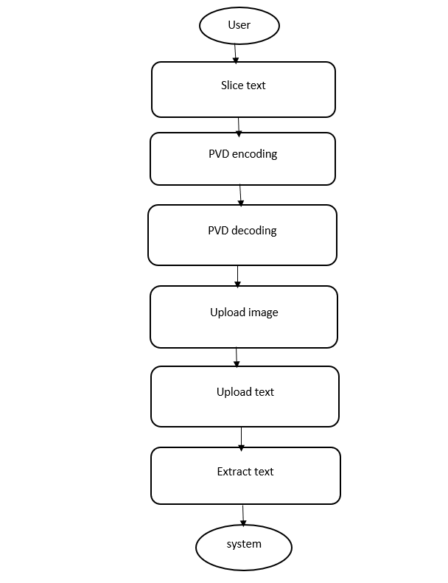
Data Flow Diagram:
Data flow diagrams illustrate how data is processed by a system in terms of inputs and outputs. Data flow diagrams can be used to provide a clear representation of any business function. The technique starts with an overall picture of the business and continues by analyzing each of the functional areas of interest. This analysis can be carried out in precisely the level of detail required. The technique exploits a method called top-down expansion to conduct the analysis in a targeted way.
As the name suggests, Data Flow Diagram (DFD) is an illustration that explicates the passage of information in a process. A DFD can be easily drawn using simple symbols. Additionally, complicated processes can be easily automated by creating DFDs using easy-to-use, free downloadable diagramming tools. A DFD is a model for constructing and analyzing information processes. DFD illustrates the flow of information in a process depending upon the inputs and outputs. A DFD can also be referred to as a Process Model. A DFD demonstrate business or technical process with the support of the outside data saved, plus the data flowing from the process to another and the end results
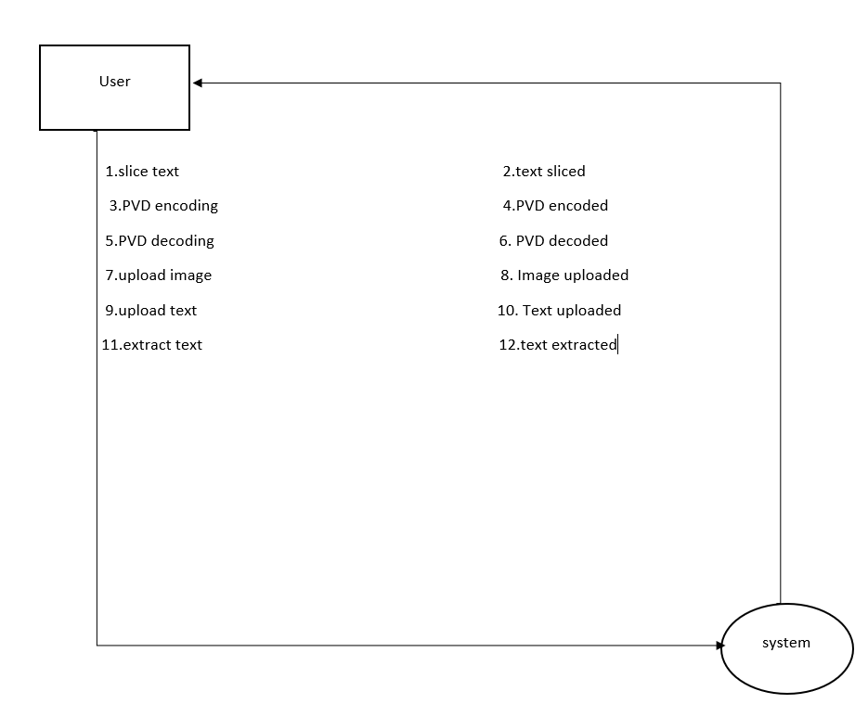

5. IMPLEMETATION
5.1 Python
Python is a general-purpose language. It has wide range of applications from Web development (like: Django and Bottle), scientific and mathematical computing (Orange, SymPy, NumPy) to desktop graphical user Interfaces (Pygame, Panda3D). The syntax of the language is clean and length of the code is relatively short. It's fun to work in Python because it allows you to think about the problem rather than focusing on the syntax.

History of Python:
Python is a fairly old language created by Guido Van Rossum. The design began in the late 1980s and was first released in February 1991.
Why Python was created?
In late 1980s, Guido Van Rossum was working on the Amoeba distributed operating system group. He wanted to use an interpreted language like ABC (ABC has simple easy-to-understand syntax) that could access the Amoeba system calls. So, he decided to create a language that was extensible. This led to design of a new language which was later named Python.
Why the name Python?
No. It wasn't named after a dangerous snake. Rossum was fan of a comedy series from late seventies. The name "Python" was adopted from the same series "Monty Python's Flying Circus".
Features of Python:
A simple language which is easier to learn
Python has a very simple and elegant syntax. It's much easier to read and write Python programs compared to other languages like: C++, Java, C#. Python makes programming fun and allows you to focus on the solution rather than syntax.
If you are a newbie, it's a great choice to start your journey with Python.
Free and open-source
You can freely use and distribute Python, even for commercial use. Not only can you use and distribute software’s written in it, you can even make changes to the Python's source code.
Python has a large community constantly improving it in each iteration.
Portability
You can move Python programs from one platform to another, and run it without any changes.
It runs seamlessly on almost all platforms including Windows, Mac OS X and Linux.
Extensible and Embeddable
Suppose an application requires high performance. You can easily combine pieces of C/C++ or other languages with Python code.
This will give your application high performance as well as scripting capabilities which other languages may not provide out of the box.
A high-level, interpreted language
Unlike C/C++, you don't have to worry about daunting tasks like memory management, garbage collection and so on.
Likewise, when you run Python code, it automatically converts your code to the language your computer understands. You don't need to worry about any lower-level operations.
Large standard libraries to solve common tasks
Python has a number of standard libraries which makes life of a programmer much easier since you don't have to write all the code yourself. For example: Need to connect MySQL database on a Web server? You can use MySQLdb library using import MySQLdb .
Standard libraries in Python are well tested and used by hundreds of people. So you can be sure that it won't break your application.
Object-oriented
Everything in Python is an object. Object oriented programming (OOP) helps you solve a complex problem intuitively.
With OOP, you are able to divide these complex problems into smaller sets by creating objects.

Applications of Python:
1. Simple Elegant Syntax
Programming in Python is fun. It's easier to understand and write Python code. Why? The syntax feels natural. Take this source code for an example:
a = 2
b = 3
sum = a + b
print(sum)
2. Not overly strict
You don't need to define the type of a variable in Python. Also, it's not necessary to add semicolon at the end of the statement.
Python enforces you to follow good practices (like proper indentation). These small things can make learning much easier for beginners.
3. Expressiveness of the language
Python allows you to write programs having greater functionality with fewer lines of code. Here's a link to the source code of Tic-tac-toe game with a graphical interface and a smart computer opponent in less than 500 lines of code. This is just an example. You will be amazed how much you can do with Python once you learn the basics.
4. Great Community and Support
Python has a large supporting community. There are numerous active forums online which can be handy if you are stuck.
5.2 Sample Code:
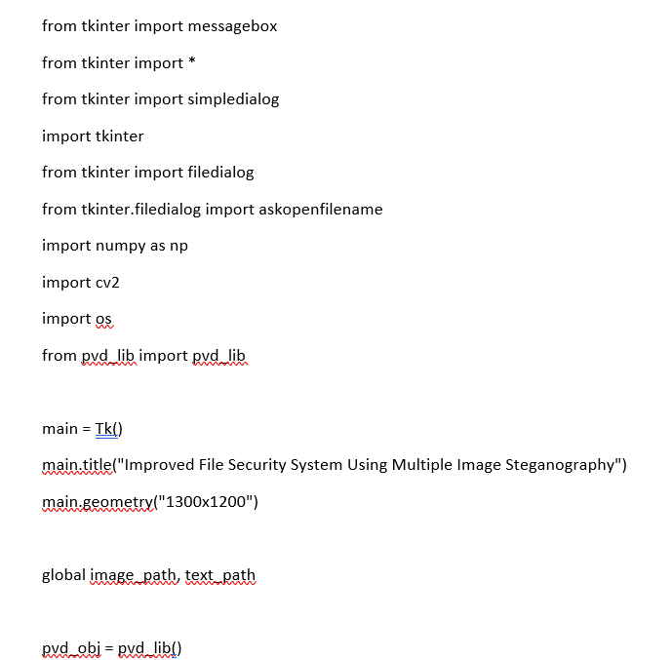
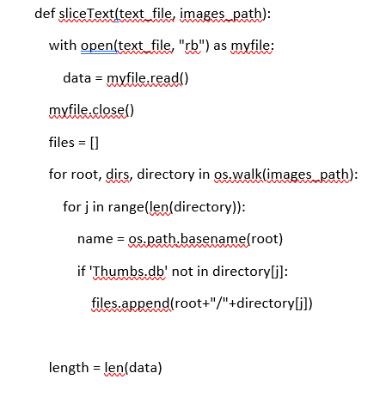
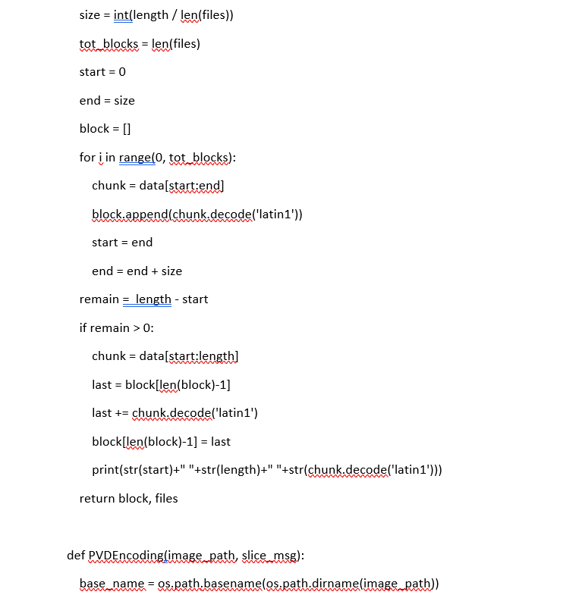
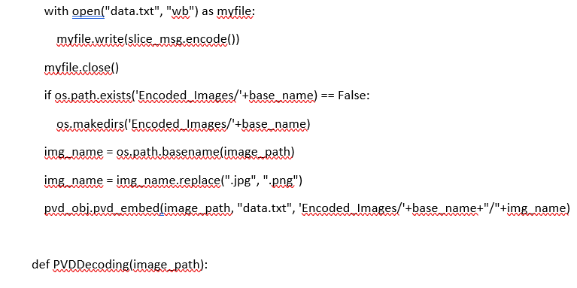
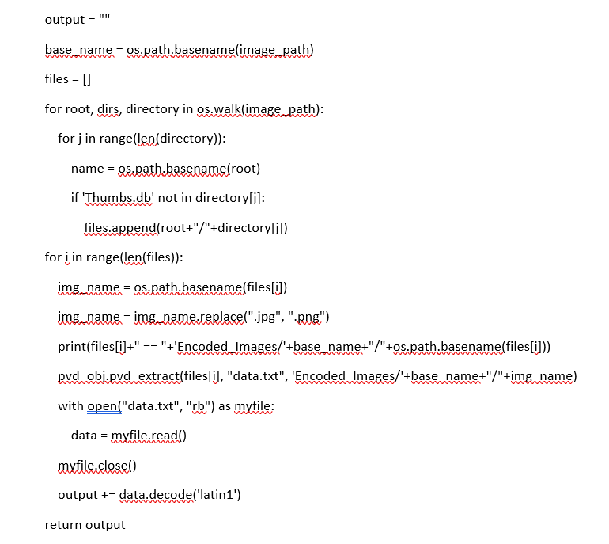
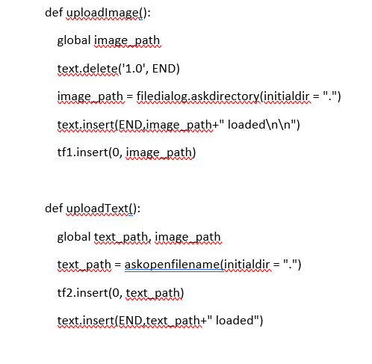
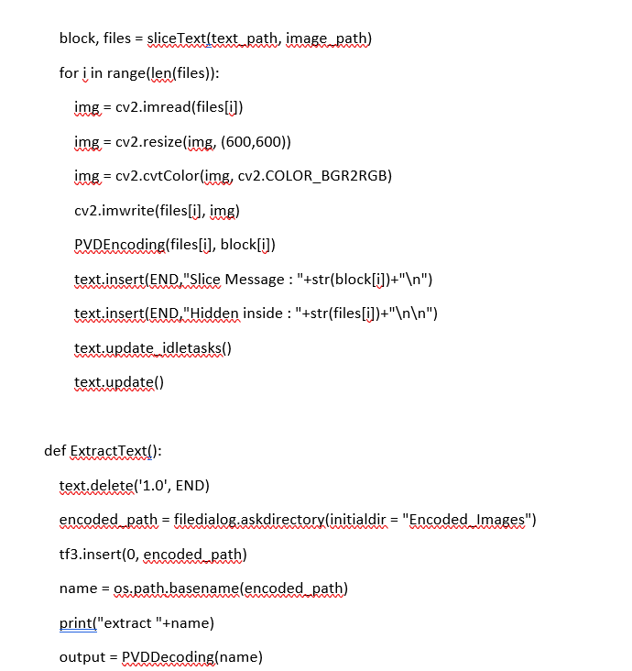
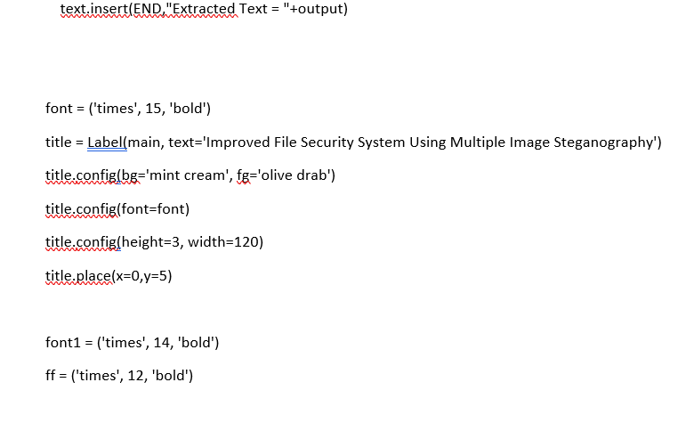
6. TESTING
Implementation and Testing:
Implementation is one of the most important tasks in project is the phase in which one has to be cautions because all the efforts undertaken during the project will be very interactive. Implementation is the most crucial stage in achieving successful system and giving the users confidence that the new system is workable and effective. Each program is tested individually at the time of development using the sample data and has verified that these programs link together in the way specified in the program specification. The computer system and its environment are tested to the satisfaction of the user.
Implementation
The implementation phase is less creative than system design. It is primarily concerned with user training, and file conversion. The system may be requiring extensive user training. The initial parameters of the system should be modifies as a result of a programming. A simple operating procedure is provided so that the user can understand the different functions clearly and quickly. The different reports can be obtained either on the inkjet or dot matrix printer, which is available at the disposal of the user. The proposed system is very easy to implement. In general implementation is used to mean the process of converting a new or revised system design into an operational one.
Testing
Testing is the process where the test data is prepared and is used for testing the modules individually and later the validation given for the fields. Then the system testing takes place which makes sure that all components of the system property functions as a unit. The test data should be chosen such that it passed through all possible condition. Actually testing is the state of implementation which aimed at ensuring that the system works accurately and efficiently before the actual operation commence. The following is the description of the testing strategies, which were carried out during the testing period.

System Testing
Testing has become an integral part of any system or project especially in the field of information technology. The importance of testing is a method of justifying, if one is ready to move further, be it to be check if one is capable to with stand the rigors of a particular situation cannot be underplayed and that is why testing before development is so critical. When the software is developed before it is given to user to use the software must be tested whether it is solving the purpose for which it is developed. This testing involves various types through which one can ensure the software is reliable. The program was tested logically and pattern of execution of the program for a set of data are repeated. Thus the code was exhaustively checked for all possible correct data and the outcomes were also checked.
Module Testing
To locate errors, each module is tested individually. This enables us to detect error and correct it without affecting any other modules. Whenever the program is not satisfying the required function, it must be corrected to get the required result. Thus all the modules are individually tested from bottom up starting with the smallest and lowest modules and proceeding to the next level. Each module in the system is tested separately. For example the job classification module is tested separately. This module is tested with different job and its approximate execution time and the result of the test is compared with the results that are prepared manually. The comparison shows that the results proposed system works efficiently than the existing system. Each module in the system is tested separately. In this system the resource classification and job scheduling modules are tested separately and their corresponding results are obtained which reduces the process waiting time.
Integration Testing
After the module testing, the integration testing is applied. When linking the modules there may be chance for errors to occur, these errors are corrected by using this testing. In this system all modules are connected and tested. The testing results are very correct. Thus the mapping of jobs with resources is done correctly by the system.

Acceptance Testing
When that user fined no major problems with its accuracy, the system passers through a final acceptance test. This test confirms that the system needs the original goals, objectives and requirements established during analysis without actual execution which elimination wastage of time and money acceptance tests on the shoulders of users and management, it is finally acceptable and ready for the operation.

Test Case Id | Test Case Name | Test Case Desc. | Test Steps |  |  | Test Case Status | Test Priority
 |  |  | Step | Expected | Actual
01 | Upload Encoding images | Test whether the Encoding images is uploaded or not | If the images is not uploaded | we cannot do further operations | If the Encoding images is uploaded we will do further operations | High | High
02 | Upload text file to hide and PVD encode | Verify the text file is uploaded  or not | If the text file is not uploaded | We cannot do further operations | If text file is uploaded We Can do further operations | High | High
03 | Upload folder to extract text and pvd decoding | Verify whether folder uploaded or not | Without folder uploaded | we cannot do further operations | If folder is uploaded We can do further operations | High | High
7. SCREENSHOTS:
Improved File Security System Using Multiple Image Steganography
In this project as per your instructions we have developed PVD (Pixel Value Differencing) based image steganography where user can upload multiple images folder and then upload text file which has to be slice and embed in all those uploaded images. All embed images will get saved inside ‘Encoded_Images’ folder with text slice data hidden inside it. While decoding we can upload desired folder from ‘Encoded_Images’ folder to extract text.
To embed text we are using below sample text file
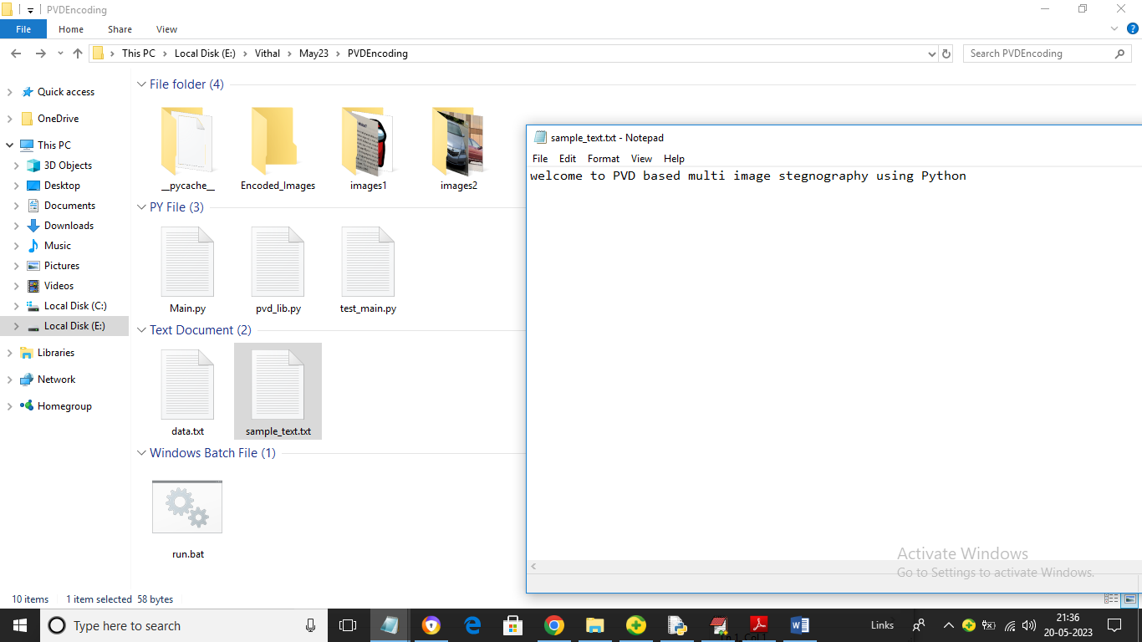
Above sample text will get sliced and hide inside multiple images
To run project double click on ‘run.bat’ file to get below output
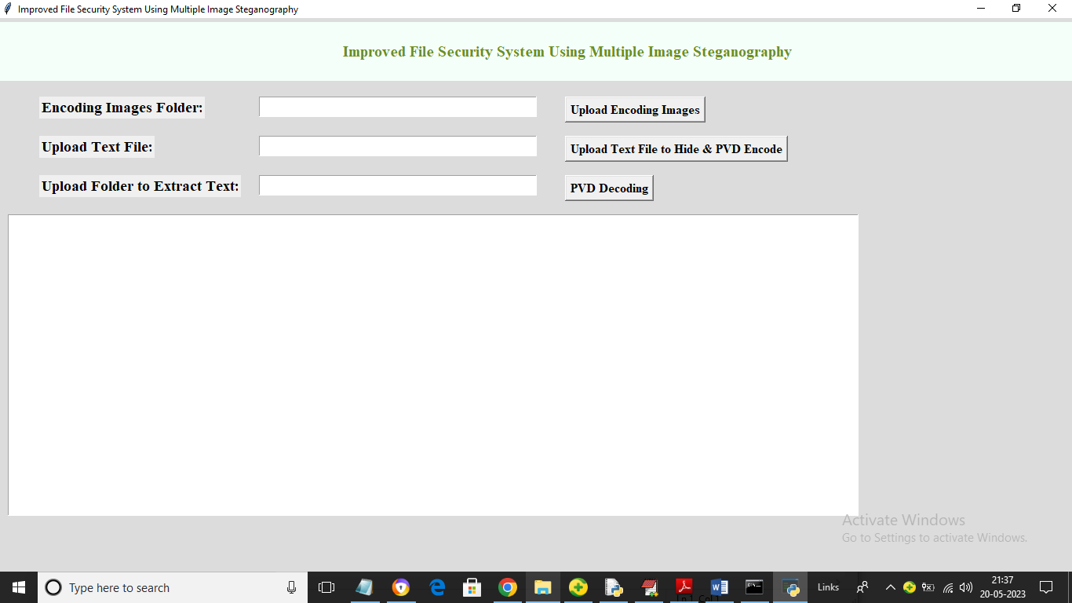
In above screen click on ‘Upload Encoding Images’ button to upload folder with multiple images like below screen
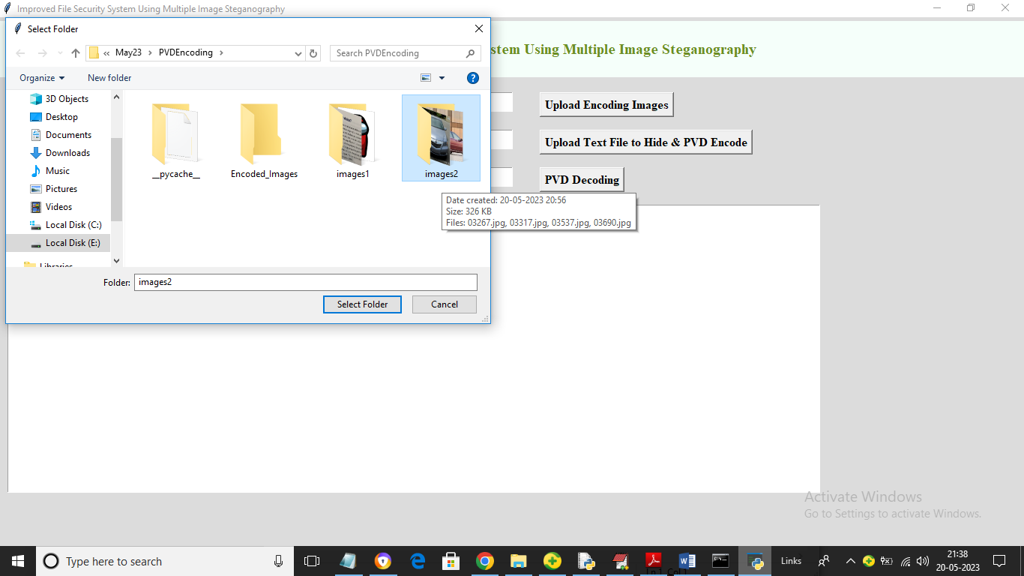
In above screen selecting and uploading ‘images2’ folder and then click on ‘Select Folder’ button to load images and get below output
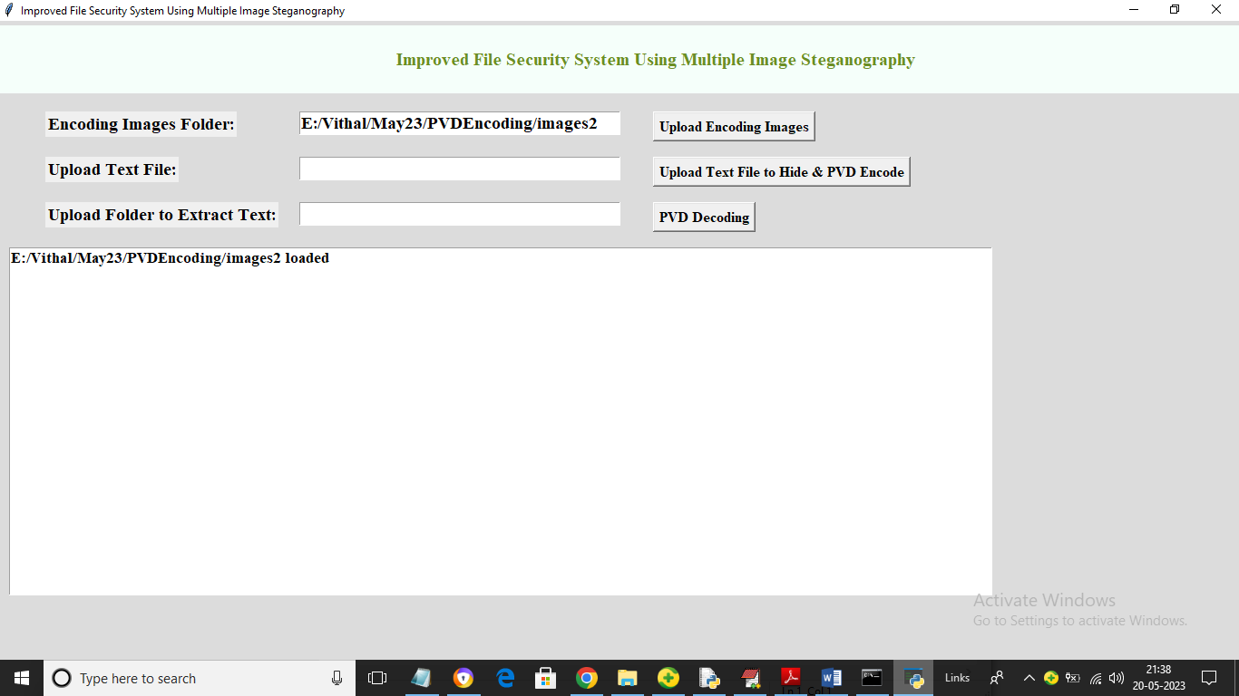
In above screen images uploaded and now click on ‘Upload Text File to Hide & PVD Encode’ button to upload sample text file to slice file and then embed in all images and get below output
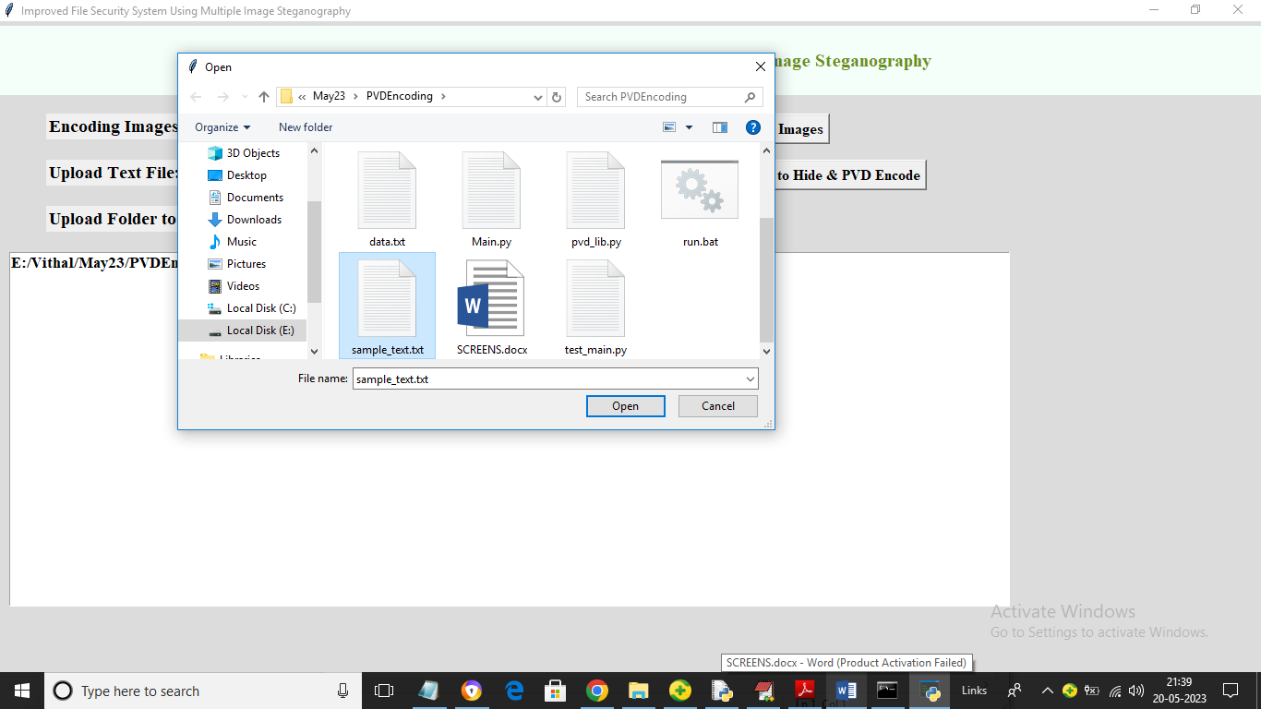
In above screen selecting and uploading ‘sample_text.txt’ file and then click on ‘Open’ button to get below output
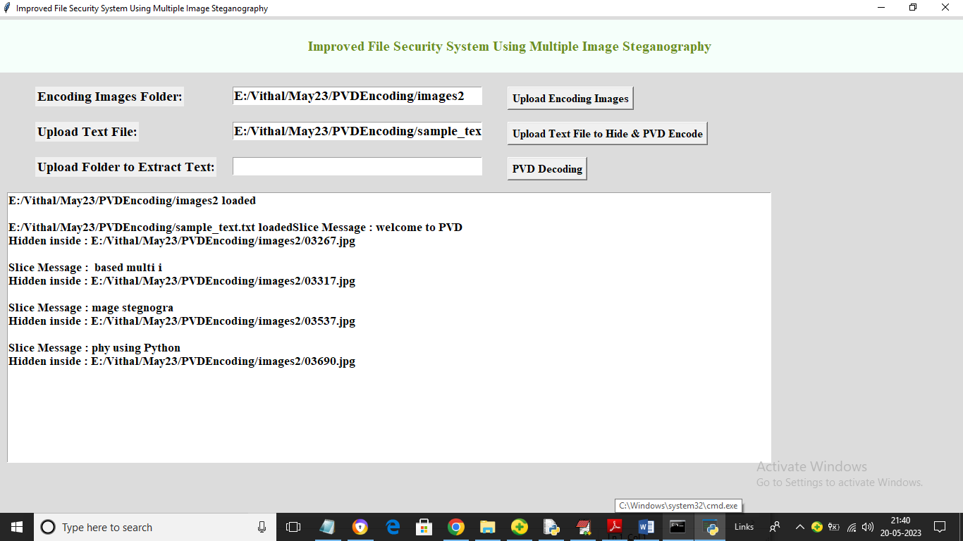
In above screen we can see in each line slice message and then can see image name which hide that slice message. In above screen in image we hide slice message as ‘welcome to PVD’ and in second image another slice message has hide and continue till all slice messages hidden inside all images. Now to extract text click on ‘PVD Decoding’ and then select desired folder from ‘Encoded Images’ folder to get below output
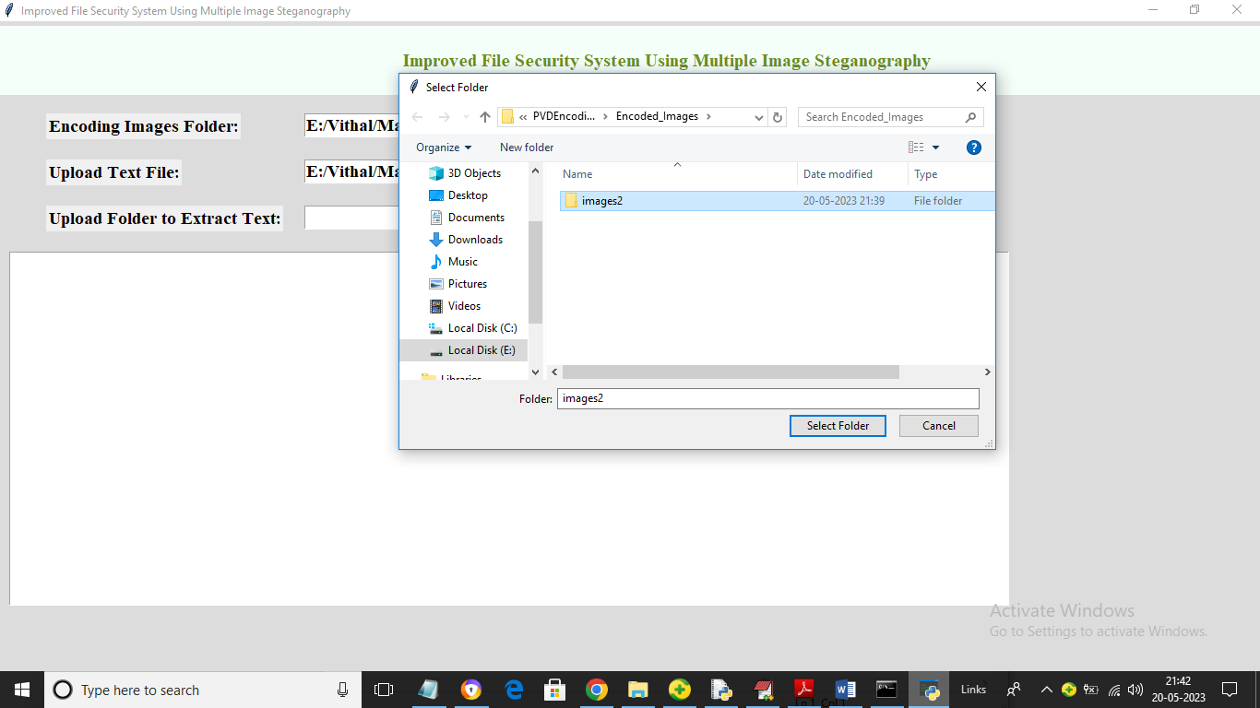
In above screen selecting and uploading ‘images2’ message encoded folder and then click on ‘Select Folder’ button to extract message and get below output
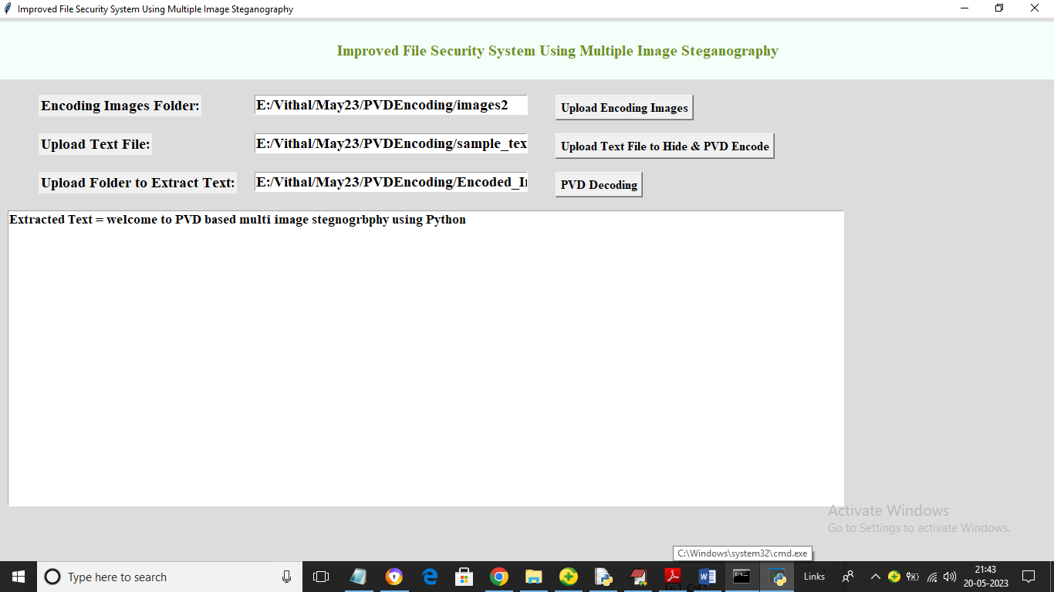
In above screen in text area we can see all hidden data extracted from all images and then displaying. Similarly you can upload images, text and then hide and extract text from them by following above screens

8.CONCLUSION:
Steganography is the process of hiding a secret message within an ordinary message & extracting it at its destination. Image steganography is one of the most common and secure forms of steganography available today. Traditional steganography techniques use a single cover image to embed the secret data which has few security shortcomings. Therefore, batch steganography has been adopted which stores data on multiple images. In this paper, a novel approach is proposed for slicing the secret data and storing it on multiple cover images. In addition, retrieval of this secret data from the cover images on the destination side has also been discussed. The data slicing ensures secure transmission of the vital data making it merely impossible for the intruder to decrypt the data without the encrypting details.
9.REFERENCES:
1. Alanazi N, Khan E, Gutub A (2020) Efficient security and capacity techniques for Arabic text steganography via engaging Unicode standard encoding. Multimed Tools Appl. https://doi.org/10.1007/s11042-020-09667-y
2. Alhaddad MJ, Alkinani MH, Atoum MS, Alarood AA (2020) Evolutionary detection accuracy of secret data in audio steganography for securing 5G enabled internet of things. Symmetry 12:2071. https://doi.org/10.3390/sym12122071
3. Alia AS, Al-Tamimib MSH, Abbood AA (2020) Secure image steganography through multilevel security. Int J Innov, Creat Change 11(1):80–103
4. Al-Nofaie S, Gutub A, Al-Ghamdi M (2019) Enhancing Arabic text steganography for personal usage utilizing pseudo-spaces. J King Saud Univ-Comput Inform Sci. https://doi.org/10.1016/j.jksuci.2019.06.010
5. Amine K (2020) Steganographic techniques classification according to image format, international. Ann Sci https://doi.org/10.21467/ias.8.1.143-149
6. Ambika, Biradar RL (2020) Secure medical image steganography through optimal pixel selection by EH-MB pipelined optimization technique. Heal Technol issue 1
7. Amsden ND, Chen L (2015) Analysis of Facebook steganographic capabilities. In: International conference on computing, networking and communications(ICNC),Garden Grove,https://doi.org/10.1109/ICCNC.2015.7069317
8. Artiemjew P, Kislak-Malinowska A (2020) Indiscernibility mask key for imagesteganography. Computers. https://doi.org/10.3390/computers9020038
9. Atee HA, Ahmad R, Noor NM, Rahma AM, Aljeroudi Y (2017) Extreme learning machine based optimal embedding location finder for image steganography. https://doi.org/10.1371/journal.pone.0170329
10. Ayub N, Selwal A (2020) An improved image steganography technique using edge based data hiding in DCT domain. J Interdisciplinary Math. https://doi.org/10.1080/09720502.2020.1731949

